**CODE:**

ASSIGNMENT-2

M.ARFIYA REG NO:960219106031

'''Build a python code, assume u get temp and humidity values (generated with random function to a variable) and write a conditon to continuously detect alarm in

case of high temperature'''

#import the necessary package! import requests

import random from time import * gate=True

#input the city name def run_city():

city = input('input the city name') print(city)

# or you can also hard-code the value #Display the message!

print('Displaying Weater report for: ' + city) #fetch the weater details

url = 'https://wttr.in/{}'.format(city) res = requests.get(url)

#display the result! print(res.text) #temprature searching while(gate):

temperature = random.randint(0,50) humidity = random.randint(10,50) if temperature>45 and humidity<50:

print("Temperature =",temperature,"Humidity =",humidity) print("Alert message in Activate")

gate=False else:

print("Temperature =",temperature,"Humidity",humidity) sleep(1);

#enter temprature value

x= int(input("Please enter the Humidity value :")) y= int(input("Please enter the temperature value :")) z=print(x,y)

print(z)

if x == 36.5:

print("Due to Temperature report you are in normal days") if x < 36:

print("your Temperature is low compare to normal days") if x > 36:

print("your Temperature is high compare to normal days")

if y == 45:

print("Due to Humidity report you are in normal place") if y < 45:

print("your Humidity is low compare to normal days") if y > 45:

print("your Humidity is high compare to normal days") while True:

**OUTPUT:**

=== RESTART:

C:/Users/ELCOT/AppData/Local/Programs/Python/Python37/as2.py === Temperature = 28 Humidity 24

Temperature = 13 Humidity 31

Temperature = 5 Humidity 16

Temperature = 5 Humidity 45

Temperature = 14 Humidity 20

Temperature = 3 Humidity 26

Temperature = 5 Humidity 33

Temperature = 27 Humidity 46

Temperature = 49 Humidity = 47 Alert message in Activate

Please enter the Humidity value :49 Please enter the temperature value :46 49 46

None

your Temperature is high compare to normal days your Humidity is high compare to normal days

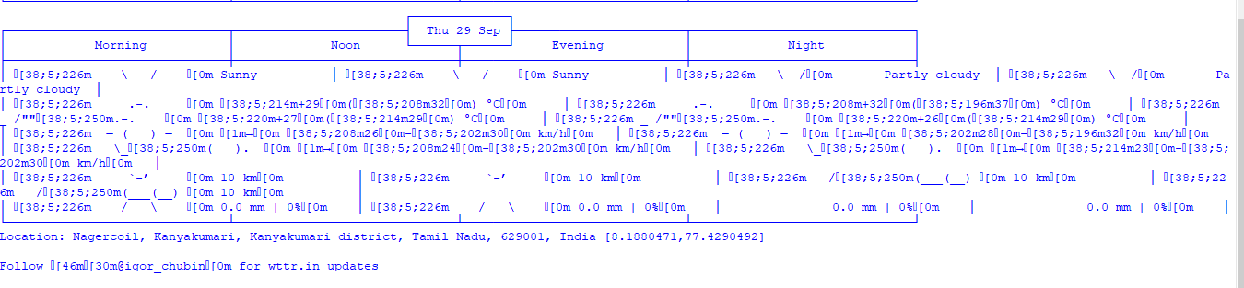input the city nameNagercoil Nagercoil

Displaying Weater report for: Nagercoil Weather report: Nagercoil

